ICS344 Secure Communication System - User Guide
Project: Cryptography in Action – Secure Messaging Application
Bucket: P01 (Python | AES-CBC PKCS#7 | Diffie-Hellman | Dictionary | Message injection | Session hijacking | Flooding messages | Desktop)
Team: ICS344 Project Team 41
Members: Muhammad Jaddoua – Husain Althagafi
Institution: King Fahd University of Petroleum & Minerals

Table of Contents
- Introduction
- System Requirements
- Installation Guide
- Getting Started
- Using the Application
- Attack Simulations
- Troubleshooting

1. Introduction
Welcome to the Secure Communication System, a desktop application designed to demonstrate cryptographic principles including encryption, key exchange, and security attack simulations. This application provides an interactive environment for understanding how modern secure communication works.
Key Features:
- AES-256-CBC encryption with PKCS#7 padding
- Diffie-Hellman key exchange
- Two-client communication simulation
- Four different attack simulations
- Real-time security event logging

4. Getting Started

Launching the Application
Once installation is complete, launch the application by running:
python GUI/main_window.py
The application window will appear with the following components:
- Client A Text Area (left panel)
- Client B Text Area (right panel)
- Control Buttons for encryption and decryption
- Attack Simulation Controls at the bottom
- System Log Panel showing security events
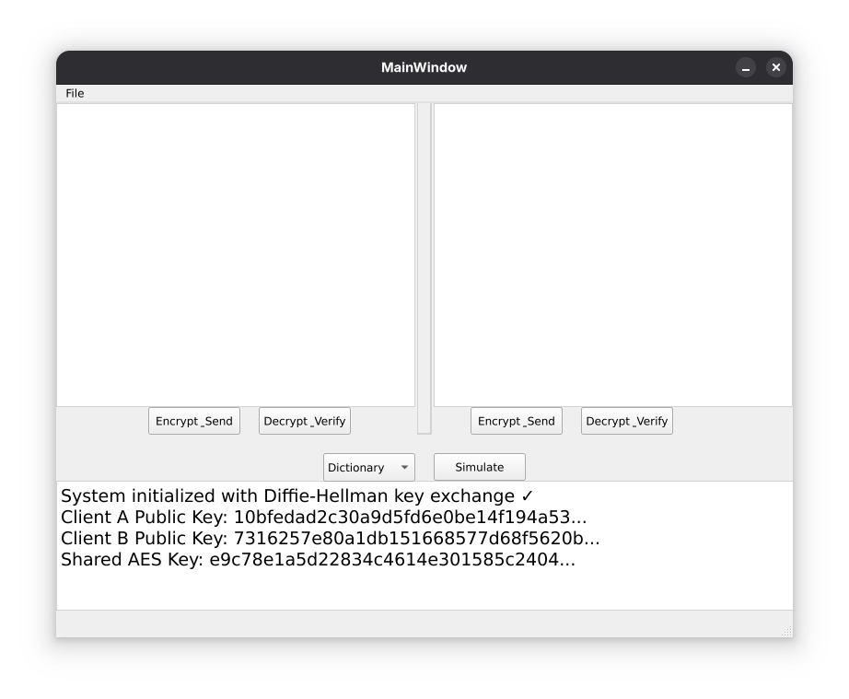Figure 1: Main application window with labeled components

Initial Key Exchange
Upon startup, the application automatically performs a Diffie-Hellman key exchange between Client A and Client B. The system log will display:
- Client A's public key
- Client B's public key
- The derived shared AES encryption key
This process happens instantly and requires no user intervention.

5. Using the Application
Figure 2: System logs showing DH key exchange completion

Sending an Encrypted Message (Client A to Client B)
Step 1: Type your message in the Client A text area (left panel).
Step 2: Click the "Encrypt & Send" button under Client A's panel.
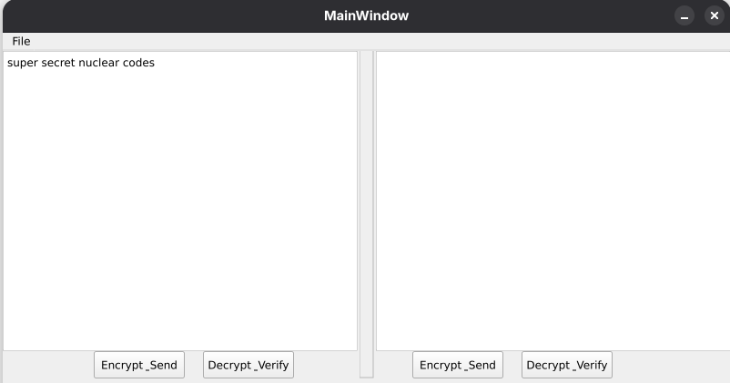Figure 3: User typing message in Client A text area
Step 3: The encrypted message (Base64-encoded ciphertext) will appear in Client B's text area (right panel).
Step 4: Observe the system log panel, which will show:
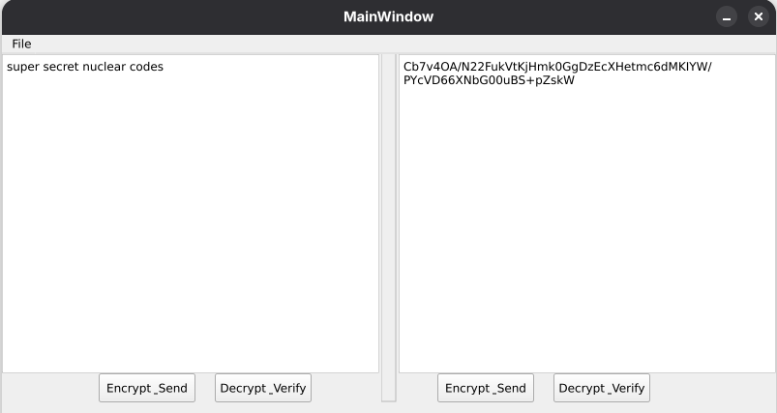Figure 4: Encrypted message appearing in Client B's text area
- "Client A: Encrypted and sent message"
- The encryption key used (first 32 characters)

Decrypting a Received Message (Client B)
Step 1: With the encrypted message visible in Client B's text area, click the "Decrypt & Verify" button under Client B's panel.
Step 2: The original plaintext message will replace the ciphertext in Client B's text area.
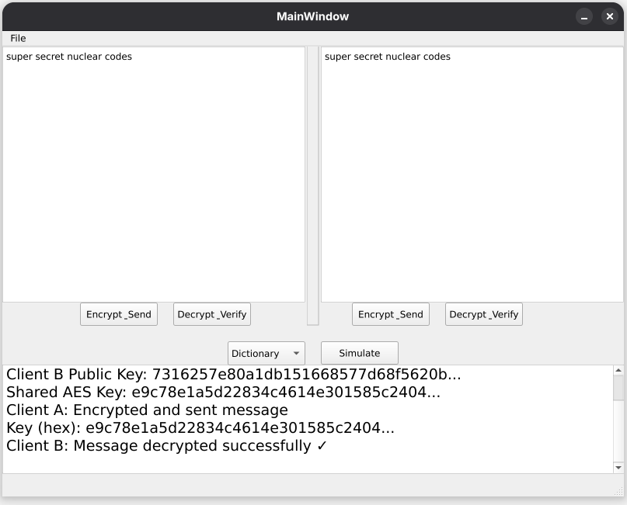Figure 5: Decrypted plaintext message in Client B's text area
Step 3: The system log confirms successful decryption with the message:
- "Client B: Message decrypted successfully ✓"

Sending Messages in Reverse (Client B to Client A)
The process works identically in the opposite direction:
- Type message in Client B's text area
- Click Client B's "Encrypt & Send"
- Encrypted message appears in Client A's text area
- Client A clicks "Decrypt & Verify" to read the message

6. Attack Simulations
The application includes four security attack simulations as specified in the project requirements. These demonstrate common threats to cryptographic systems and how they are defended against.
NOTE: Some output are not fully displayed in the figures due to their length. Log window is moved to show the start of the corresponding output for demonstration purposes.

Dictionary Attack
Purpose: Demonstrates the computational infeasibility of brute-forcing AES-256 encryption keys.
Steps to Simulate:
- Select "Dictionary" from the attack type dropdown menu
- Click the "Simulate" button
- Watch the system log as it attempts common passwords
- Observe that all attempts fail due to the massive AES-256 key space (2^256 possibilities)

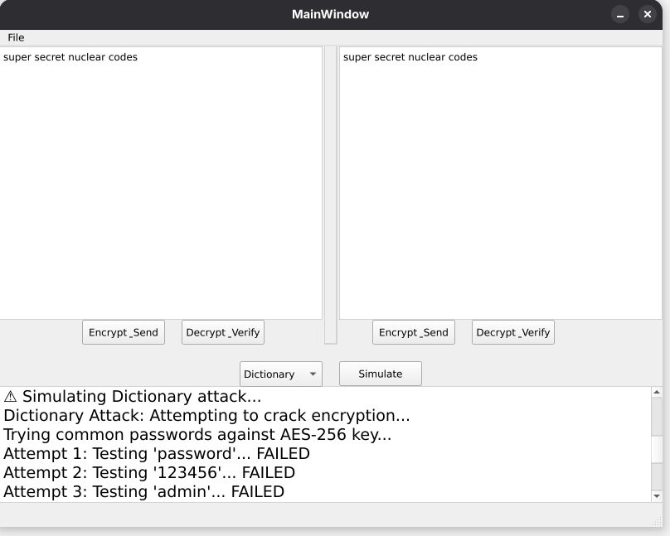Figure 6: Dictionary attack simulation in progress with failed attempts in logs
What You'll See:
- Multiple password attempts logged
- Each attempt marked as "FAILED"
- Final message: "Dictionary Attack: Failed - AES-256 key space is 2^256"
- Explanation: Key space is too large and thus is not feasible to search, as well as since the key is not one of the common passwords it won’

Message Injection Attack
Purpose: Shows that encryption provides confidentiality but not necessarily integrity or authenticity.
Steps to Simulate:
- Select "Message Injection" from the dropdown menu
- Click "Simulate"
- A forged encrypted message ("HACKED MESSAGE") is injected into Client A's text area
- The attacker successfully encrypts the message using the captured shared key
What You'll See:
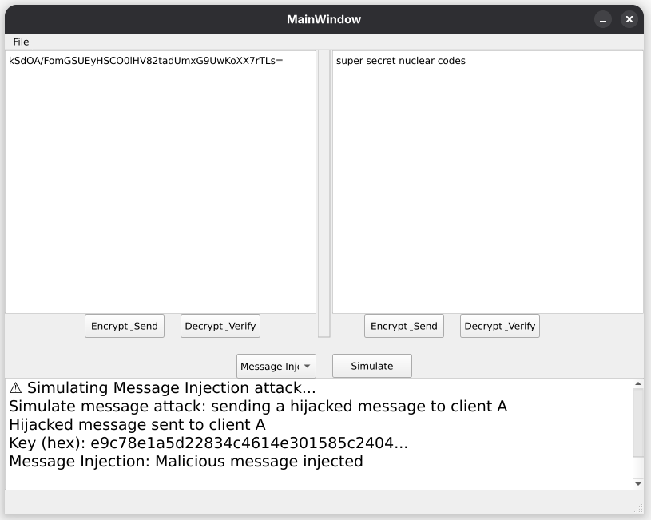Figure 7: Message injection attack showing forged message
- Log message: "Simulate message attack: sending a hijacked message to client A"
- The forged encrypted message appears in the text area
- Logs show the key used for encryption
- This demonstrates why message authentication (HMAC/signatures) is necessary

Session Hijacking (MITM Attack)
Purpose: Demonstrates that Diffie-Hellman is secure against passive eavesdropping but explains the need for authentication.
Steps to Simulate:
- Select "Session Hijack" from the dropdown menu
- Click "Simulate"
- The simulation shows an attacker attempting to intercept the key exchange
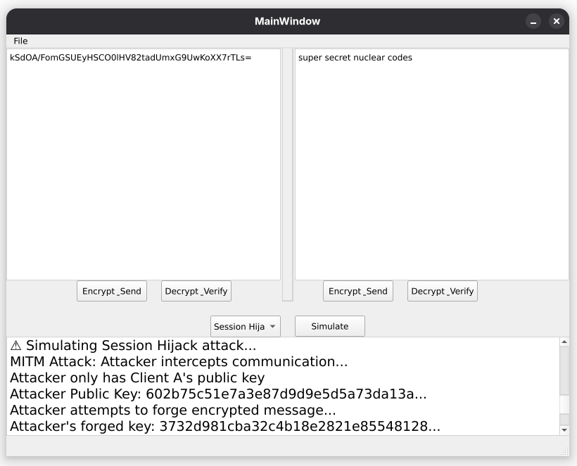Figure 8: Session hijacking simulation showing attacker's failed key computation

What You'll See:
- "MITM Attack: Attacker intercepts communication…"
- Attacker's forged public key displayed
- Comparison between attacker's forged key and the real shared key
- "Keys don't match! ✓"
- "MITM Attack: FAILED - DH is secure against passive eavesdropping ✓"
- Note about needing digital signatures for active MITM prevention

Flooding Messages Attack
Purpose: Simulates a Denial of Service (DoS) attack through rapid message transmission.
Steps to Simulate:
- Select "Flooding Messages" from the dropdown menu
- Click "Simulate"
- Watch as multiple messages are rapidly encrypted and logged
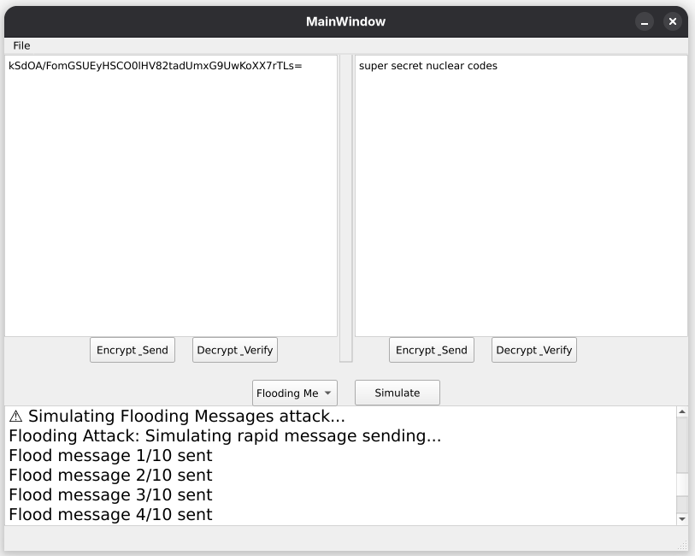Figure 9: Flooding attack showing multiple rapid messages in logs

What You'll See:
- "Flooding Attack: Simulating rapid message sending…"
- Ten flood messages logged in quick succession
- "Flooding Attack: Completed"
- Defense recommendations: "Rate limiting should be implemented" and "Connection throttling recommended ✓"

